8:00-8:45: Breakfast and Registration
Redbud Room, IMU
The registration table will remain open until 10:30 AM.
8:45-10:15: Session 1
Literature: Puerto Rico’s Place: Rethinking the Politics of Belonging through Narrations of the Diaspora
Moderator: Ellen Ryan Robinson, Indiana University
Sassafras Room, IMU
  - “Delinquency and the Dignity of Dirt: Performing Place in Two Puerto Rican Dramas”
Daryl Spurlock, Indiana University
  - “’We hold these truths to be self-evident’: Hamilton, Adaptation, and American History”
Zachary Scalzo, Indiana University
  - “The Formative Power of Women, Story-Telling, and Writing in Judith Ortiz Cofer’s Silent Dancing”
Alba Rivera, Purdue University
Linguistics: Second language acquisition/Bilingualism
Moderator: Jordan Garret, Indiana University
Persimmon Room, IMU
  - “El efecto del grado de oclusión y duración de [β ð ɣ] en la percepción de acento extranjero”
Megan DiBartolomeo & Fernando Melero García, Indiana University
  - “Effects of explicit and implicit instruction on the Spanish past subjunctive”
Sara Fernández, University of Illinois Urbana-Champaign
  - “Echt Papiamentu in context: an analysis of Dutch and English lexical contributions to Papiamentu”
Margaret Glide, Indiana University
10:30-11:45: Keynote Address by Professor Joan Bybee
Dogwood Room, IMU
“Does Grammar Impact Sound Change?”
11:45-1:15: Lunch Break
1:15-2:45: Session 2
Literature: Race and Gender in the Lusophone World
Moderator: Rebecca Clay, Indiana University
Sassafras Room, IMU
  - “The Racialized Cinematic Stare in Leon Hirszman’s São Bernardo”
Ellen Ryan Robinson, Indiana University
  - “Úrsula, Discovering Afro-Brazilian Literature”
Nilzimar Vieira, Indiana University
  - “Quebrando tabus, seguindo convenções: O papel da mulher como educadora em "O sermão do senhor cura" de Ana de Castro Osório e Opúsculo humanitário de Nísia Floresta”
Ricardo Martins, Indiana University
Linguistics: Phonetics
Moderator: Sean McKinnon, Indiana University
Persimmon Room, IMU
  - “Cordoba Spanish: A closer look to Eastern Andalusian mid-vowels”
Ángel Milla Muñoz, Indiana University
  - “What the ‘L?: An Ultrasound Study of the Acoustic and Articulatory Characteristics of /l/ in Brazilian Portuguese”
Sherman Charles, Indiana University
  - “Proposed Effects of Plurilingualism on Rhotic Realizations: A Closer Look at the Guatemalan Spanish Dialect”
Sarah Little, University of Illinois Urbana-Champaign
3:00-4:30: Session 3
Literature: Interrogando identidades en la literatura de la temprana modernidad
Moderator: Christie Cole, Indiana University
Sassafras Room, IMU
  - “Articulando la identidad nacional en El bastardo Mudarra de Lope de Vega”
Ali Alsmadi, Indiana University
  - “La ebriedad y la representación de la feminidad en el Archipreste de Talavera”
Min Ji Kang, Purdue University
  - “¿La homosexualidad de Francisco Roca?”
Luis Cárdenas López, University of Louisville
Linguistics: Sociolinguistics/Pragmatics
Moderator: Vanessa Elias
Persimmon Room, IMU
  - “Pragmaticalization and Variation of Epistemic Markers in Puerto Rican Spanish Slang: A Variationist Approach to CMC”
Juan Escalona, Indiana University
  - “A Usage-Based Approach to Adjectival Predicates Language Contact in Castellón, Spain”
Travis Sago, Indiana University
  - “Who's Usted? Address Form Variation in Service Encounters in Medellin, Colombia”
Eliot Raynor, Indiana University
4:45-6:00: Keynote Address by Professor Erin Graff Zivin
Dogwood Room, IMU
“The Ethical Turn in Latin American Studies”
8:00-8:45: Breakfast and Registration
Redbud Room, IMU
The registration table will remain open until 10:30 AM.
8:45-10:15: Session 4
Literature: La plaza del diamante: Nuevas aproximaciones desde la perspectiva de género
Moderator: Jackie Markle, Indiana University
Sassafras Room, IMU
  - “El periplo de Natalia en La plaza del Diamante”
Gabriela Kolman, Indiana University
  - “La señora Enriqueta, las langostas y la relación familiar en La plaza del Diamante”
Jill Fortin, Indiana University
  - “Not man Enough: Investigating La plaza del Diamante’s Mateu”
Caitlin McClelland, Indiana University
Literature: El deseo, la nación y lo fantástico en el boom latinoamericano
Moderator: Alysa Shcroff, Indiana University
Persimmon Room, IMU
  - “Una exploración fantástica de la pedofilia en ‘La muñeca reina’”
Andrew Holzman, Western Michigan University
  - “Una lectura política de El recurso del método de Alejo Carpentier: El Primer Magistrado frente al Estudiante”
Damian Escolano, Indiana University
  - “La alteridad entre dos mundos: el mundo occidental y el mundo Mexica en ‘Axolotl’”
Viridiana Hernández, Western Michigan University
10:30-12:00: Session 5
Literature: Estudios culturales: España
Moderator: Nora Gardner, Indiana University
Sassafras Room, IMU
  - “Memoria, Guerra Civil y nacionalismo en la prensa española contemporánea: Las controversias sobre los Papeles de Salamanca y el Archivo Centelles (2004-2009)”
Ernest Carranza, The Ohio State University
  - “Evolución e imposición lingüística en los archivos parroquiales catalanes en el siglo XVIII (el caso de Miravet)”
Josep Cañabate, Universitat de Barcelona
Literature: History and its Shadows: Re-Thinking Historical Narratives in Contemporary Latin American and Luso-Brazilian Literature
Moderator: Tamara Mitchell, Indiana University
Persimmon Room, IMU
  - “Between Fradique Mendes and Gilberto Freyre: The Possibility for a Luso-Tropicalist Reading of José Eduardo Agualusa’s Nação Crioula”
Cynthia Martinez, Indiana University
  - “La recodificación de lo histórico en lo personal en La diáspora de Horacio Castellanos Moya”
Tingting Zhang, Indiana University
  - “Geopolítica de la Amazonía and Evo Morales: Echoes of Latin American History”
Daniel Runnels, Indiana University
12:00-1:30: Lunch Break
1:30-3:00: Session 6
Literature: Reading Ana Ozores
Moderator: Moses Fritz, Indiana University
Sassafras Room, IMU
  - “The Politics of Description in the Realist Novel: Reading La Regenta with Jacques Rancière”
Matt Johnson, Indiana University
  - “Vetusta’s Venerated Virgin/Venus: Ana Ozores as Celebrity in Leopoldo Alas’s La Regenta”
Nora Gardner, Indiana University
  - “The Body and Soul of don Santos Barinaga: La Regenta as Biopolitical Allegory”
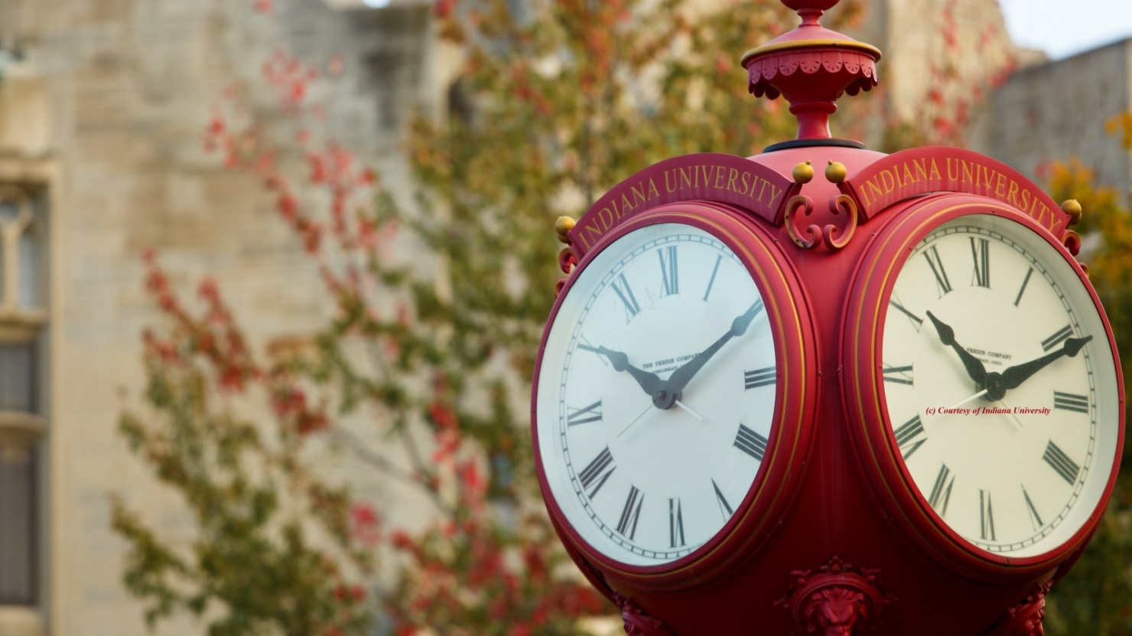
Justin Knight, Indiana University

